
RETRO SERIES – TRADE REFERENCE GUIDE - FOR FULL SPECIFICATIONS VISIT:
www.retropoollights.com info@selectpoolproducts.ca 1-855-881-0889
EXAMPLES OF EXISTING LIGHTS IN THE FIELD | SIZE OF NICHE | REPLACE WITH: |  | PART NUMBERS
T1 TITAN RETRO
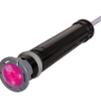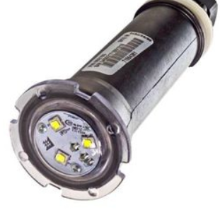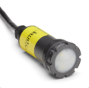 | 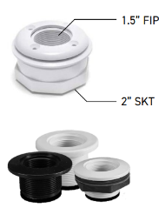 |  | T1 – TITAN  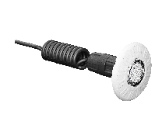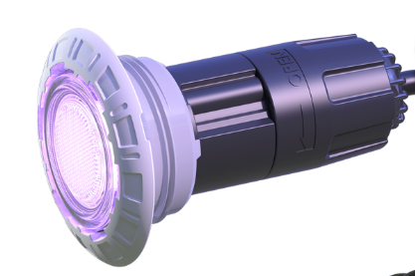 | T1L12C1WMP – STANDARD WHITE TRIM  T1L12C1GMP – STANDARD GREY TRIM  T1GL12C1MP – GLOBRITE  T1KL12C1WMP – CARVIN (WHITE RIM)  T1KL12C1GMP – CARVIN (GREY RIM)
EMRX-AQUA/LAMP RETRO
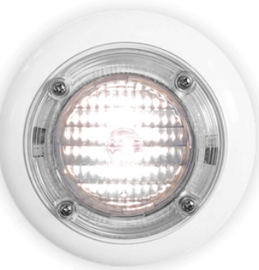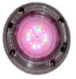 | 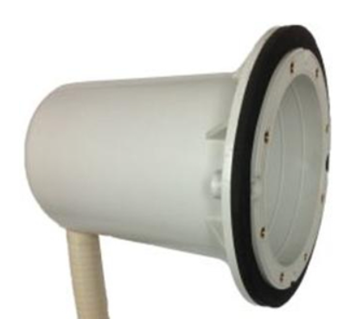 |  | EMRX   | EMRXL12WMPL (WHITE TRIM)  EMRXL12GMPL (GREY TRIM)
R6 RETRO
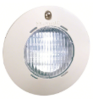 | INNER DIMS OF NICHE MUST BE:  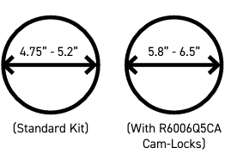 |  | R6   | R6CL12C1WMP (WHITE TRIM)  R6CL12C1GMP (GREY TRIM)  *R6V0021CAWH or GY (VINYL DRESS RINGS)  *R6006Q5CA (Q500 CAM LOCKS)
R8 RETRO
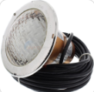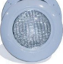  SWIMQUIP/HAYWARD PRO SERIES | INNER DIMS OF NICHE MUST BE:  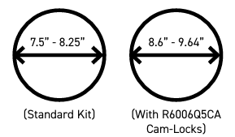 |  | R8 RETRO  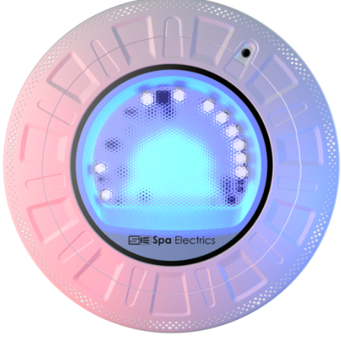 | R8CL12C1WMP (WHITE TRIM)  R8CL12C1GMP (GREY TRIM)  *AVAILABLE IN 3K OR 4 K WHITE VERSIONS
R10 RETRO
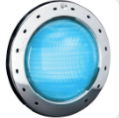 | INNER DIMS OF NICHE MUST BE:  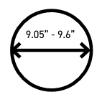 |  | R10 RETRO | R10CL12C1WMP (WHITE TRIM)  R10CL12C1GMP (GREY TRIM)  *R10V0021CAWH OR GY (VINYL DRESS RINGS)  *ADAPTOR AVAILABLE FOR CONCRETE HAYWARD SHALLOW NICHE  *ADAPTOR AVAILABLE FOR AQUALUMIN  *AVAILABLE IN 3K OR 4 K WHITE VERSIONS

